Smart Wearables Summit Draws Industry Leaders to Discuss Latest Hot Topics in Shenzhen

The Smart Wearable Device Asia Pacific Summit (SWAP) 2020, hosted by Duxes, took place at the Marco Polo Hotel in Shenzhen, China, from January 13-14. SWAP attracted hundreds of industry leaders from around the world to exchange ideas on trends, opportunities and the development of the latest wearable devices and smart products for the international market.

This year’s SWAP summit featured a wide range of speakers and experts from the world of smart wearables in the Asia-Pacific region and beyond, who came together to discuss the latest trends, regulations and hot topics affecting the fast-growing technology sector. The first day of the event focused on “Market analysis and industry prospects”, whilst the second day concentrated on “The future of smart wearable devices.”

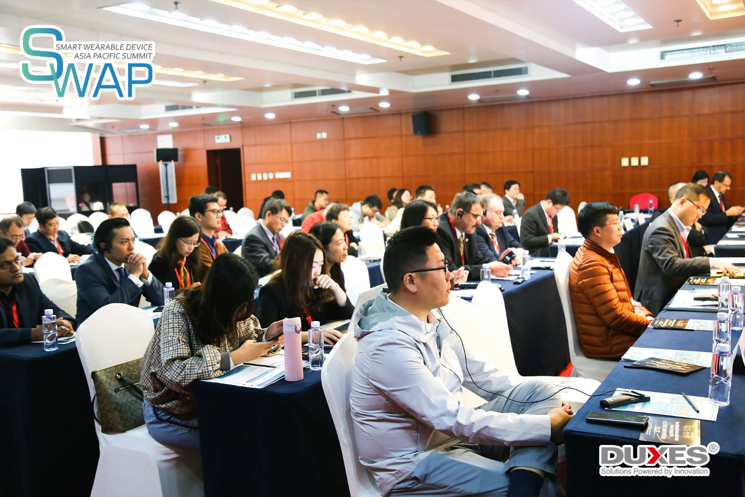

The presentations at the summit included those by highly-regarded professionals from many major tech companies, manufacturers, analysts and product developers from around the world and the APAC region such as Alibaba, ASUS, Samsung, Huawei, Huami, HTC, Gentle Monster, Cyrcadia Asia, IDC and China National Standardization Technical Committee.

Speakers gave presentations on the impact of 5G and the development of wearable AI-powered computing; how to create smart immersive applications through the use of AR/VR; and, how healthcare providers are tapping into wearables as a way to improve patient care and monitoring, among a variety of other topics.

On the first day, Winfred Chen, Chief Hardware Architect of the IoT (Internet of Things) Division at Alibaba, gave a presentation titled "The Way to IoT Smart Devices". He described how forecasters predict a strong rise in the number of shipments of IoT-enabled products over the next two years, especially in fields such as entertainment, home automation and safety. One of his company’s current missions is the “intelligent integration of people, things and cloud computing in the digital world,” he said.

Chen described how Alibaba is further developing its own ambitious IoT-enabled platform which connects all of the ecosystems of the company, from virtual assistants through to payments and mapping. The wide-reaching AliOS Ecosystem already “services 140 categories of equipment… and over 100 million units have been installed," he told attendees.

Later, Damon Hernandez, Product Manager at Samsung Research America, spoke on “Wearables: The Key to Unlocking the Immersive World”. In his presentation, he explained the huge potential for the use of AR and VR in enterprises, for example as an aid for training, maintenance and manufacturing, as well as in consumer products with a focus on gaming and location-based experiences.

He said that “the web is the next immersive platform” and that Samsung was hoping to create “a new type of user experience across devices” as envisioned through futuristic products such as mobile reality capture, mashups of different wearables, and new in-ear devices drawing upon the functionality of AI.

The first day also included a fascinating panel discussion on “The Arrival of Data Services for the Smart Wearable Devices Industry” featuring the invaluable contributions of Andy Liu, CEO of CW Data Technologies, Randy Wang, Product Director at ASUS and Wang Lin, Council Member and assistant to the president of Zhengzhou Konggang Academy of Artificial Intelligence.

On the second day, Rob Royea, CEO of Cyrcadia Asia, an innovative medical devices startup based in Hong Kong, spoke about introducing wearable AI products into the healthcare system in Asia. In his presentation, he said that products such as his company’s wearable cancer-detection device, are all part of a wider trend of “empowered monitoring” and the promotion of healthy aging.

AI is developing at a rapid pace and can be used to offer better predictive health care and streamline services, he explained. He also went on to describe how China is currently one of the global centers of AI research, and remarked “the East is on the rise!” He also noted that “China aims to lead the world in AI technologies by 2030.”

Later in the afternoon, advanced materials expert and former Apple designer Simon Lancaster, who is currently Head of Consumer Products at Arris Composites, delivered an inspiring talk titled “How Materials Innovation is Driving the Future of Wearable Devices”.

Lancaster discussed current trends in materials for wearable consumer electronics and their applications, including the use of modern functional composites to make products ever smaller and lighter. He said the most innovative products of tomorrow would be inspired by the layered design of printed circuit boards (PCBs) and added: “The future of wearables design will be highly functional, electromechanical designs incorporating material, function and structure.”

In addition to the extensive program of talks, networking events and discussions, this year’s Summit also featured the Smart Wearable Device Asia Pacific Industry Awards 2020, hosted on Monday evening by Royea. The awards announced at the ceremony were:

Annual Excellent Smart Headworn Device Award
RealWear

Annual Smart Medical or Healthcare Wearable Application Award
Huami

Annual Gold Supplier of Smart Storage Solutions
Biwin

Annual Product Innovation Design Award
GOWIN Semiconductor – Little Bee GW1NRF

Annual Excellent Third-Party Consulting Service Supplier
Exponent
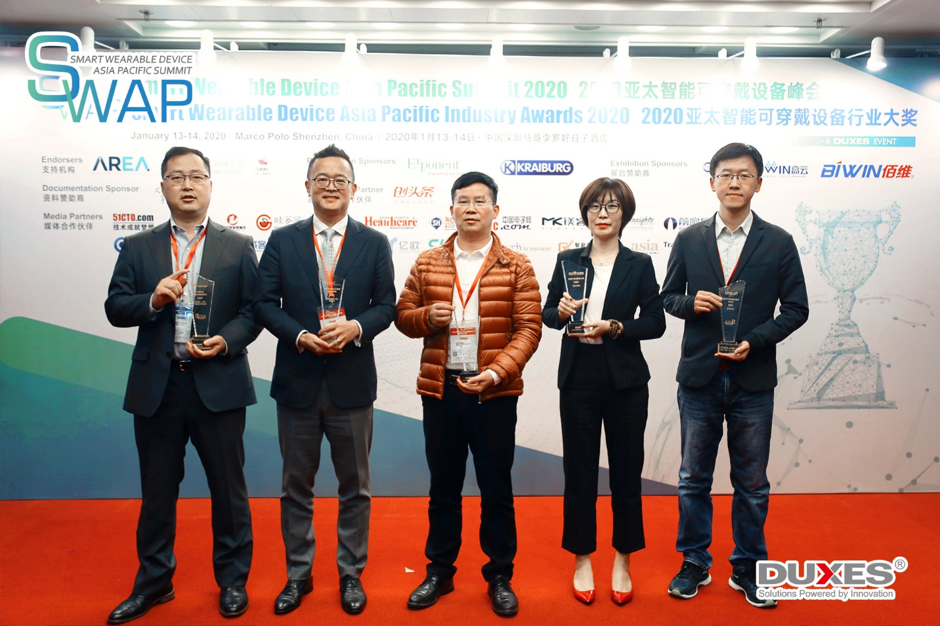

Following the ceremony, Tu Youkui, Head of the Embedded Department at Biwin met with industry journalists who covered the event and featured the winning company in several media articles. The Summit was widely publicized in Asia-Pacific media, raising awareness for all of those companies that took part and boosting the profile of the smart wearable devices industry as a whole.

Duxes is grateful to all of our distinguished speakers for having taken time out of their busy schedules to attend SWAP 2020 and to share such noteworthy opinions on these matters of industry importance. Duxes also wishes to show their appreciation to Exponent and Kraiburg for their presentation sponsorship, and to GOWIN, TÜV SÜD and Biwin for their exhibition sponsorship. The organizer would also like to thank Tegent for their documentation sponsorship, and AAI, the Augmented Reality for Enterprise Alliance (AREA) and Shenzhen Internet Society for their endorsement of the event.

Lastly, thanks to the numerous organizations who have made SWAP 2020 possible with their strong support!

If you missed this summit, don’t worry; you can still catch up from anywhere in the world by downloading the XEvents app on your mobile device. Create an account and login to view the complete presentation materials from the event and get full access to all our online webinars!

Stay up-to-date on the latest industry trends and the most authoritative policy interpretations by subscribing to the official Duxes WeChat account here:

Or following the XEvents industry community:

Duxes is also pleased to add that there are several related forums taking place soon as part of the Duxes Hi-tech Series and Duxes Healthcare Series. These include:

NFAP
5th Healthcare Policy Asia Pacific Summit 2020
April 16-17, Singapore

PNCS
International Personalized Nutrition Co-development Summit 2020
May 28-29, Shanghai

SWAP
4th Smart Wearable Device Asia Pacific Summit
December 3-4, Shenzhen

For more information and to book your tickets today, please visit: http://www.duxes.cn/DuxesEventCalendar/index.html

